Article ID: 1124
Article Name: How do I clean my washing machine?
Topic Location: Laundry Washing machine Usage
Meta-data: Performance, cleaning, care, maintenance
Related Articles: RA_500_Check drain (general) RA_500_Check filter (general)
Related Questions: Why does my washing machine smell?
PNC
DIY
Safety
Link
Email
Book Engineer
Multimedia
Brand
Article Content:

Before maintenance, deactivate the appliance and disconnect the Mains plug from the mains. Do not disconnect any electrical or functional component without first consulting Electrolux as this may invalidate your warranty.

CLEANING YOUR WASHING MACHINE

The recommendation is to only clean the appliance with soap and water. Cleaning products affect the softening agents in the plastic which makes it brittle and scratches. See also the user instructions for servicing the appliance. The relevant component can perhaps be replaced by our Distriparts department. The information below gives some guidance:

- Undertake a 95°C service wash with a Washing Machine cleaner to prevent smells and marks around the door
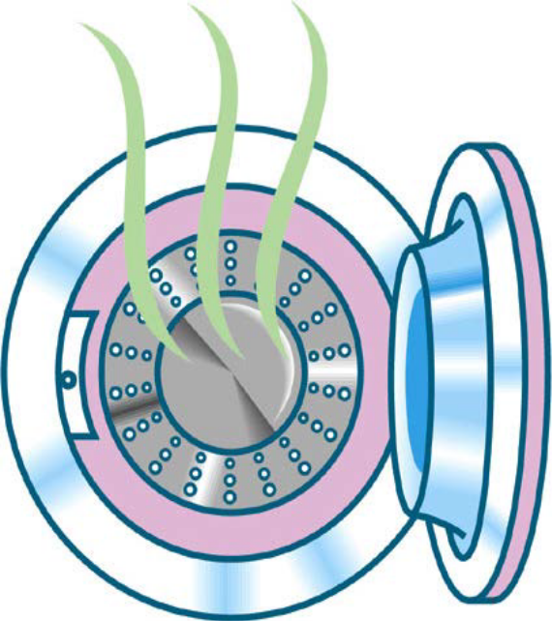

- Follow steps below for correct cleaning of the filter:
- Switch Off the appliance;
- Open door of filter compartment and place drip tray underneath;
- Drain the machine by opening the drainage hoses beside the filter;
- Remove the filter by turning this (sometimes firmly) counter-clockwise;
- Clean the filter and pump housing under running water and re-install the filter;
- Close drainage hose and place this back in original position;
- Close door of filter compartment;
The appliance is now ready for use again; check for leakages when first running a cycle

The information above is an approximate guide only. You can also refer to the full instruction in our articles section:
RA_500_Check drain (general)
RA_500_Check filter (general)

- Cleaning your dispenser drawer
Mould and mildew can build up from time to time.
Clean any spills or residue in each compartment by running under warm tap water. Take out the drawer and use a suitable brush to clean all debris and dried soap/liquid from the individual sections ( an old toothbrush may do the trick)

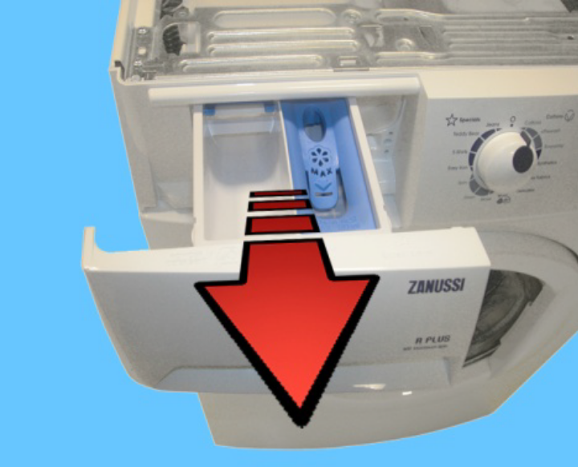

- Cleaning the seal or gasket of my washing machine

Rubber seals on washing machines are prone to dark or black mould spots. You can remove this mould using washing soda crystals, thick bleach or dishwasher cleaner, this will help dissolve any stubborn mould and soap scum. Ensure you use some rubber gloves and some eye protection whilst doing the actual cleaning.

- Exterior
Washing machines are often made of baked-on enamel. The best solution is a cleaning cloth with a mild all-purpose cleaner or dish soap. Gently wipe down the exterior surface of the washing machine. You may find that lint and drizzled laundry soap have formed thick sticky spots on the washing machine. A little warm water and a cleaning rag are usually enough to get the area cleaned. For corners and edges, try cleaning with a cotton swab.
DO NOT USE HARD ABRASIVES

- Hard Water Issues
If you experience limescale build up from hard water, water softeners added to your laundry detergent may be a workable solution

You should not find a need to book an engineer for cleaning advice unless your appliance is showing a fault. Please refer to your User Manual for further assistance and visit our Webshop for recommended cleaning products.
http://shop.electrolux.co.uk/category/Accessories/Laundry
http://shop.aeg.co.uk/index.html
http://shop.zanussi.co.uk/index.html

